**Lab 01**

**Set up the Working Environment**

**Objective:**

The objective of this lab is to set the development enviroment for creating data warehouse.

**Activity Outcomes:**

On completion of this lab student will be able to

* Install SQL SERVER 2019-Enterprise Edition
* Install SQL SERVER Management Studio (SSMS)
* Install and integrate SQL SERVER Data Tool (SSDT)

**Instructor Note:**

As pre-lab activity “See SQL Server installation guide” by Microsoft Docs.

<https://docs.microsoft.com/en-us/sql/database-engine/install-windows/install-sql-server?view=sql-server-ver15>

1. **Useful information**

**Microsoft SQL Server**

Microsoft SQL Server is a relational database management system (RDBMS) that supports a wide variety of transaction processing, business intelligence and analytics applications in corporate IT environments. Microsoft SQL Server is one of the three market-leading database technologies, along with Oracle Database and IBM's DB2.

**SQL Server services, tools and editions**

Microsoft also bundles a variety of data management, business intelligence (BI) and analytics tools with SQL Server. In addition to the R Services and now Machine Learning Services technology that first appeared in SQL Server 2016, the data analysis offerings include SQL Server Analysis Services, an analytical engine that processes data for use in BI and data visualization applications, and SQL Server Reporting Services, which supports the creation and delivery of BI reports.

On the data management side, Microsoft SQL Server includes SQL Server Integration Services, SQL Server Data Quality Services and SQL Server Master Data Services. Also bundled with the DBMS are two sets of tools for DBAs and developers: SQL Server Data Tools, for use in developing databases, and SQL Server Management Studio, for use in deploying, monitoring and managing databases.

1. **Solved Lab Activites**

|  |  |  |  |
| --- | --- | --- | --- |
| ***Sr. No*** | ***Allocated Time*** | ***Level of Complexity*** | ***CLO Mapping*** |
| ***Activity 1*** | ***30 minutes (May vary due to system and internet speed)*** | ***Low*** | ***CLO-5*** |
| ***Activity 2*** | ***1 hour (May vary due to system and internet speed)*** | ***Low*** | ***CLO-5*** |
| ***Activity 3*** | ***30 minutes (May vary due to system and internet speed)*** | ***Low*** | ***CLO-5*** |

**Activity 1:**

***This activity demonstrate the steps to be followed to install SQL server, SSMS, SDT on the system.***

**Solution:**

**Downloading SQL Server Installer**

Microsoft SQL Server Download site

You will find the Developer addition download from the Microsoft SQL server download site.

<https://www.microsoft.com/en-us/sql-server/sql-server-downloads>

Once the download is complete, go to the destination folder (i.e. *downloads* folder on your computer). The installation file will look something like this:



Click on the install file to begin the install process.

# Installing SQL Server Developer Edition

1. Once the installation starts, you will be presented with installation type. We will focus on the

**Custom** install and explain various features of the installation.

**Figure 1.1: Installation step one**

1. Choose the **Media Location** path. Note the minimum free space and download size and press

### Install.

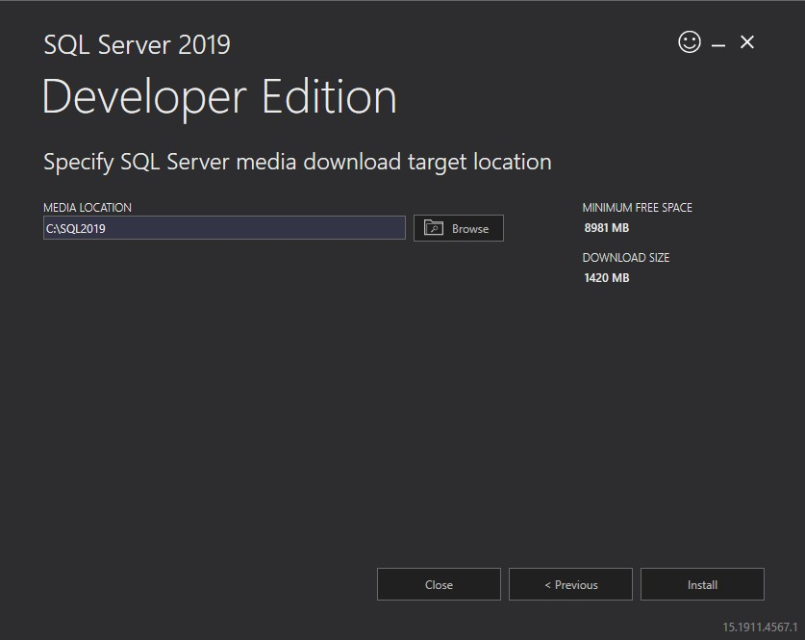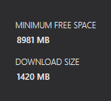

**Figure 1.2: Installation step two**

1. Once the SQL Server Installation Center launches choose **Installation** tab (second from the right).
2. In most cases you will want to run a **New SQL Server New SQL Server stand-alone installation**, but other options are available, for example if you have a previous version of SQL Server installed, you have an option to update.

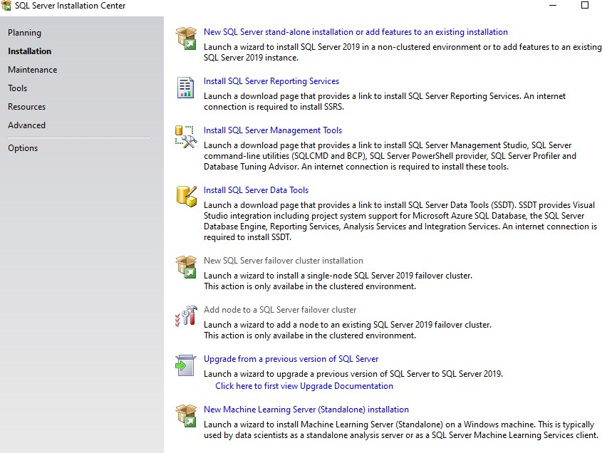

**Figure 1.3: Installation step three**

1. On the Product Key page make sure that the selected Edition is “**Developer**” click *Next*.

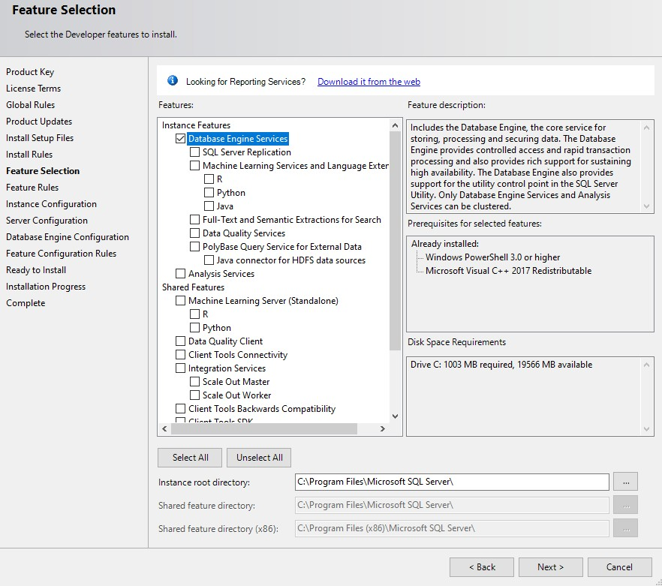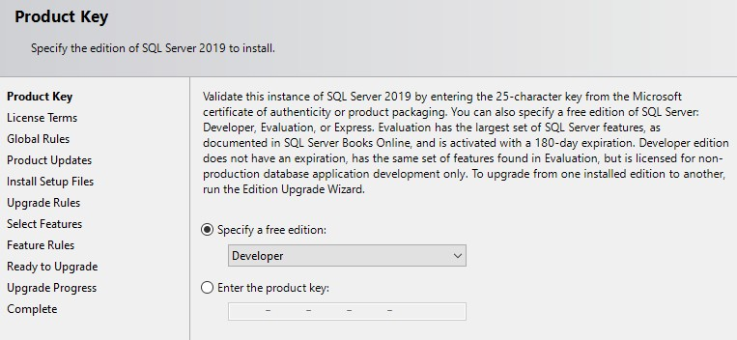

**Figure 1.4: Installation step four**

1. On the License Terms page, check the box next to *“I accept the license terms”* and click *Next.*
2. Setup will check if needed install Setup Support Files. Click **Next** when complete.

## Feature installation:

1. Select the components of SQL server to install on your computer.

Select **Database Engine Services,** this is the minim requirement to use SQL Server

* + For CS779 in addition to what is listed above please review these descriptions to see which features you might be interested in for advanced topics for the term project.
  + Instance root Directory and Shared Features Directory: Note the paths where SQL server will install the components (default is Program Files folder within C drive.)nstance Configuration

1. Generally, you can leave the Default Instance and the default Instance ID. The Named instances would be used if you want to create multiple instances of SQL Server on the same machine. Click Next when complete.

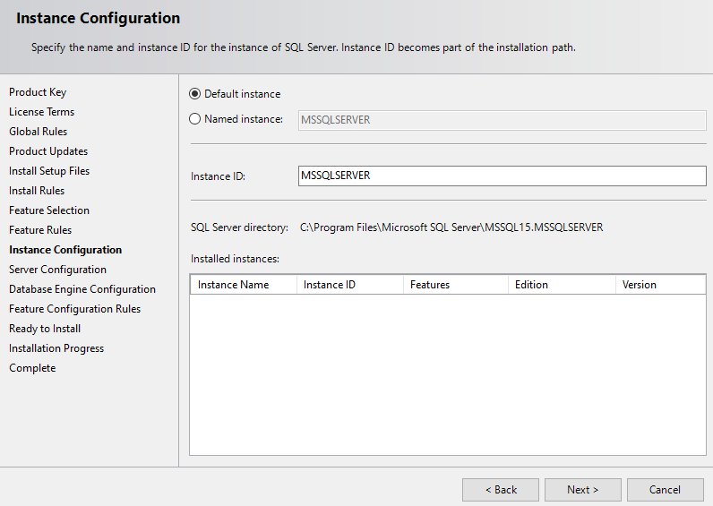

**Figure 1.5: Installation step five**

**Server Configuration**

1. Review Server Configuration options.
2. Account Names: We suggest that you leave these set to defaults provided by the installer as outlined below.
3. Startup types: If you would like to have SQL Server running at all times on your computer, the Startup Type should be Automatic (which is the default) otherwise you can set it to Manual and start it when you need to use SQL Server so that it does not take up system resources such as RAM. Leave the other services to default (Manual & Disabled).

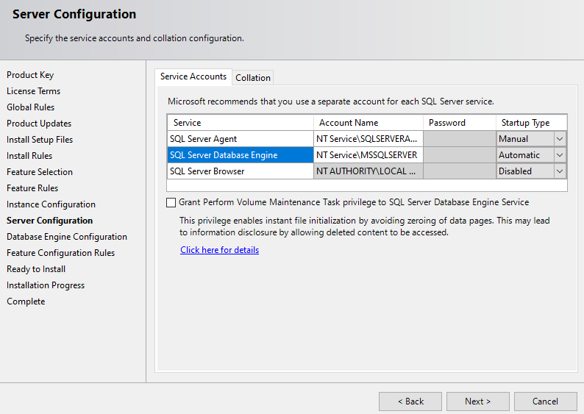

**Figure 1.6: Server Configuration**

* A few additional detailed explanations:

1. **SQL Server Agent** is used for running scheduled jobs, such as backups, scheduled SQL scripts and db maintenance. If this was a production environment you would want this service set to automatic.
2. You will need **SQL Server Database Engine** to run SQL Server. Since DBMS uses a lot of system recourses, we would recommend running it manually when you need it.
3. If you installed other components for SQL Server for advanced topics, you should also set them to manual so that they don’t run on system startup.
4. SQL Server Browser can be left disabled.
5. You do not need to select Grant Perform Volume Maintenance Task privilege to SQL Server for the course, however if performing installs in production environments this is recommended for data confidentiality. Note the link on the page for additional details.
6. Check the collation tab at the top. For our purposes this can be left at default, SQL_Latin1_General_CP1_CI_AS, which is Latin1-General case insensitive accent sensitive. Collation defines the sorting rules, case and accent sensitivity for character data, for example you can choose a different language or set it to be case sensitive. Some applications require for you to choose a specific collation. You can click *Customize* to change it. Click *Next* when done.

**Figure 1.7: Server Configuration**

## Database Engine Configuration

### Server Configuration:

* + Authentication mode:
    - Windows authentication: will only use your windows account privileges to connect to SQL Server.
    - Mixed mode: adds a local SQL system administrator (SA) account **IMPORTANT**: We highly recommend using **Mixed Mode** so that there is an additional built in SA account with a separate user name and password as well as your built-in windows account in case you have issues logging in.
  + **IMPORTANT**: Make sure to add users (such as your account) to SQL Server Administrators (click on **Add Current User**) if it is not already there.
  + These accounts will allow you to log into SQL Server.
  + Note that the server itself does not need these accounts and runs as a service which you specified in previous step.

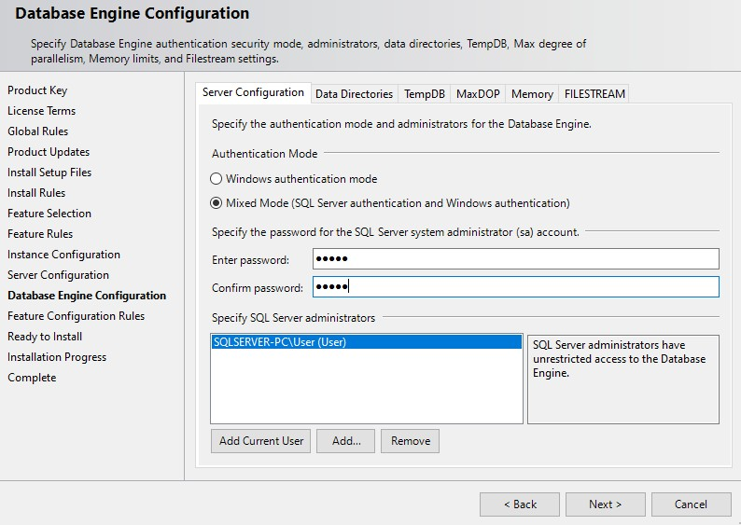

**Figure 1.8: Database Engine Configuration**

* + A few additional detailed explanations:

a. You can leave Data Directories to defaults. Data Directories can be changed if you have a multiple disk environment and for performance want to separate out where different parts of the DBMS go. For example, in production environments the LOG components should go on a separate disk array, which will improve performance of the system.

* + For additional tuning you can explore the TempDB, Max Degree of Parallelism and Memory settings. TempDB system database used by SQL Server. For additional details please review the following link: <https://msdn.microsoft.com/en-us/library/ms190768.aspx> As an example, this page allows you to customize auto-growth settings for the TempDB. For the courses leaving the defaults is fine.
  + If you are installing SQL Server for CS779 you might want to enable FILESTREAM if you plan to explore large file types such as Binary language objects (BLOB). As with many other features, this can be enabled at a later time.

## Error Reporting, Installation Configuration Rules, & Ready to Install

* Graphical user interface, text, application

  Description automatically generatedReview selected features and click **Install**, Installation will begin, this will take some time.

**Figure 1.9: Ready to Install**

* This will take some time
* Once the installation is complete Congratulations SQL Server Install is complete, click close.

**Figure 1.10: Installation Progress bar**

# SQL Server Management Tools

You will need SQL Server Management Tools to work with SQL Server, this is the user interface that include components such as the Query interface as well as components for advanced topics such as analysis and integration services as well as the database tuning advisor. SQL Server, like other modern relational databases, uses a client-server architecture. The database itself is the server and contains all of the data and the capability to add, modify, delete, and access the data. A client is needed to connect to the database and perform specific commands. The most popular client by far for SQL Server is SQL Server Management Studio (SSMS), which you will install in this section. SSMS is very capable and provides many powerful conveniences and capabilities.

### Graphical user interface, application Description automatically generatedIt is required that you install the Management Tools Complete for all courses.

## Figure 1.11: SSMS Selection for Installation

**Activity 2:**

***This activity demonstrate the steps to be followed to install SQL Server Management Studio (SSMS) on the system.***

**Solution:**

## Download SQL Server Management Studio (SSMS)

You will be brought to a web page to download the latest release of SQL Server Management Studio. Click on the link to download the latest release and save the file to a location you can remember.

Install SQL Server Management Studio (SSMS)

Once downloaded, run the SSMS installer. The first screen that appear is shown below.

**Figure 1.12: SSMS Installation step one**

Click the “Install” button to begin. A progress screen will appear similar to the following.

**Figure 1.13: SSMS Installation step two**

Let it progress through until completion, then you will see a screen indicating successful setup, click close. Congratulations! SSMS is now installed.

# Working with and connecting to SQL Server

You have installed both SQL Server and SSMS. There are just a few more steps you need in order to start using your database to complete assignments -- connecting to your database and creating a database for assignments.

## Starting & Stopping SQL Server (optional)

**IMPORTANT**: If during setup you selected for SQL Server to **start manually** then you will need to start SQL Server services. Click on Search at the bottom of the Winds screen and type in **Services** in the search

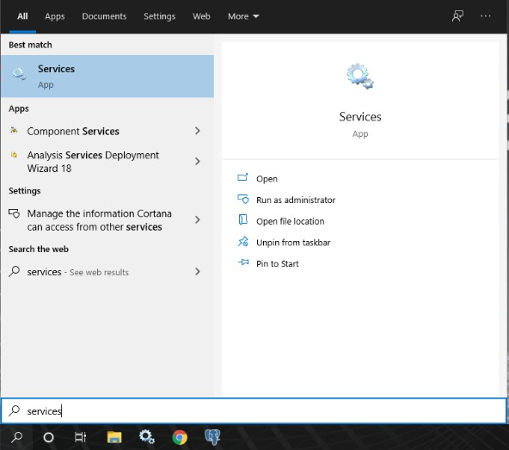

**Figure 1.13: SSMS Installation step three**

* Graphical user interface, text, application

  Description automatically generatedScroll down the list until you see the SQL Server services.

**Figure 1.14: SSMS Installation step four**

* Start the following service: SQL Server (Instance Name)

**Figure 1.15: SSMS Installation step five**

* Graphical user interface, text, application

  Description automatically generatedSQL Server service should now show that it is running

**Figure 1.16: SSMS status**

### Notes:

* When you are no longer using SQL Server, you can shut the service down to save on system resources.
* You can also change the startup type to be automatic while the course is running to save you the step of turning this on and off.
* You may want to put the services shortcut to your desktop for quick access

## Starting SQL Server Management Studio

* Graphical user interface, application, Word

  Description automatically generatedTo work with SQL Server, you will use the **SQL Server Management Studio.** You will find it under Microsoft SQL Server Tools program group or type in in the Windows Search bar.
* You may want to put the SQL Server Management Studio shortcut to your desktop or pin it to the Windows Task bar for quicker access.

## Connecting SQL Server

* In the Connect to Server dialog box:
  + Server Type: Database Engine (default)
  + Server Name: This is your system name (default).
  + Authentication: Use
    - Windows Authentication (default) and your account OR
    - The SQL Server Authentication with Login: SA and password which you created during the install and click **Connect**.

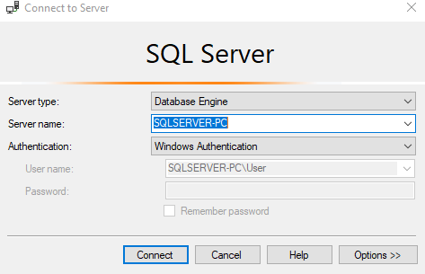

**Figure 1.18: Connecting SQL server**

You have just connected to your database through SQL Server Management Studio!

**Activity 3:**

***This activity demonstrate the steps to be followed to install SQL Server Data Tools (SSDT) on the system.***

**Solution:**

# Installing SQL Server Data Tools (SSDT)

SQL Server Data Tools (SSDT) is a modern development tool for building SQL Server relational databases, databases in Azure SQL, Analysis Services (AS) data models, Integration Services (IS) packages, and Reporting Services (RS) reports. With SSDT, you can design and deploy any SQL Server content type with the same ease as you would develop an application in Visual Studio.

### Install SSDT with Visual Studio 2019

If Visual Studios 2019 is already installed, you can edit the list of workloads to include SSDT. If you don’t have Visual Studio 2019 installed, then you can download and install Visual Studios 2019 .

To modify the installed Visual Studio workloads to include SSDT, use the Visual Studio Installer.

1. Launch the Visual Studio Installer. In the Windows Start menu, you can search for "installer".

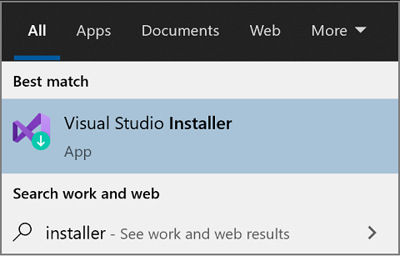

**Figure 1.19: SDT Installation step one**

1. In the installer, select for the edition of Visual Studio that you want to add SSDT to, and then choose **Modify**.
2. Select **SQL Server Data Tools** under **Data storage and processing** in the list of workloads.

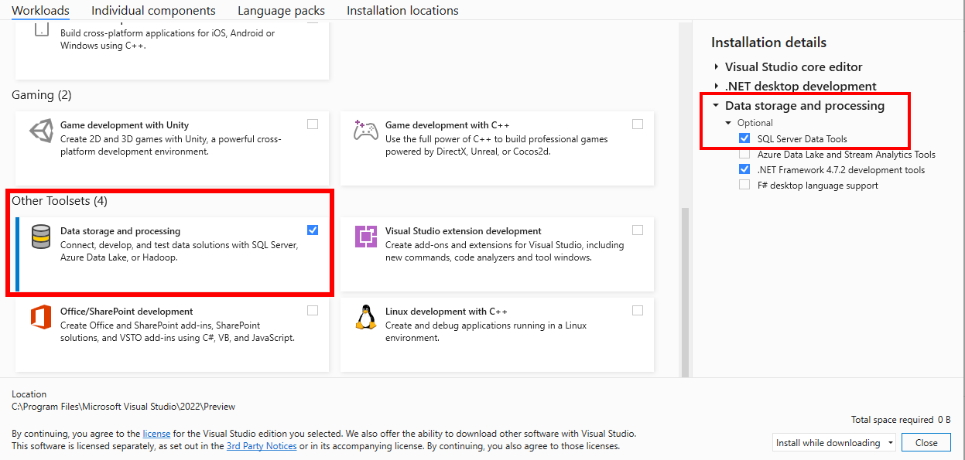

**Figure 1.20: SDT Installation step two**

1. **Graded Lab Tasks**

***Note: The instructor can design graded lab activities according to the level of difficult and complexity of the solved lab activities. The lab tasks assigned by the instructor should be evaluated in the same lab.***

**Lab Task 1**

Students are required to install the required development environment before starting the lab activities.